**Software Demonstration**

**Introduction**

* As Managers, you will know what your best & worst performing areas are & where to concentrate on improvement & what you should do to fix them
* Your reporting to top PLN Management will be very simple, as this system will give you all the data you need at your fingertips
* You can be part of a great change with PLN to go from reactive to planned maintenance & enjoy the best TLOD & TROD performance in East Java
* Everything brought together into one system
* There is two level user for demo:
  + User Level : (username: [pln_user@gmail.com](mailto:pln_user@gmail.com)) (password: pln123)
  + Admin Level : username & password like your ordinary password, different of these two user level is if admin level have admin tools and inspectools

**Log In Page**

* Note that we can change this picture to anything you want & it could be based on photos from staff (photo competition maybe)
* Note we can have access levels ranging from the whole country down to each circuit only & this could be with or without cost data depending on PLN requirements

**User Dashboard**

* Note that users can set up the dashboard with many different choices of tables or charts
* Note that they can view from Region right down to just circuit
* Show that they can view different time periods (just drop down the menu only)
* Show the compare function to look at previous results
* Advise the whole system will be able to be used in Bahasa (we need to finish off the concept with PLN in English first)
* Show the numbers on the charts by floating over with mouse point
* Go to dashboard preferences & show how this works (just show different tabs)
* Go to User Defined Issues Alert settings & explain & show both pages. They can define a particular region, APP, circuit & set criteria for maximum issues so that this will notify them when they are exceeded on their dashboard

**CAM System Modules**

* Go to the Asset Register Module
* Explain the table shows all of the tower assets in the area selected in the table
* Select – East Java > Surabaya (note how the amount of assets changes in the tables moving through the more specific area selection) > Gresik Tandes
  + Explain how each node has a link to the specific tower asset (don’t select though)
* Go back to selecting – Jakarta & Tangerang > Jakarta > Kembangun Gandul
  + Show how you can select either the power station or any asset tower by either using the drop down menu or selecting the node
* Select the Gandul Substation just to show them they will be included
* Go back and select T.57 from the map
  + Show both tables for the asset information & note we can put any other information that they may need
  + Go to the first table & then select the access information icon
  + Show that as part of the survey, we will ensure that full information is available about moving between each tower with notes
  + Show the launch position picture. While still on this page, show the drop down menu for the asset and select T61. Explain that it will take you to this asset at the same level as the previous asset. This allows very easy navigation to deeper, going up and also going sideways navigation with the software
  + Go back to the Asset page for T.61
  + Select inspection reports

**Inspection Modules**

* Select Inspection Reports (T.61)
* Explain they will have a record of all UAV inspection reports that have been done
* Note that there is a table that shows the last inspection report, next scheduled inspection report & status
* Select the top inspection report
  + Explain that you can either select which image you want to view from the tables or by selecting the boxes with the pictures
  + Go to the top view picture
  + Go back and select the Identified Issues item
  + Note that all issues will be identified by CAM inspectors & logged. The terminology that CAM uses will be based on what is shown that was given to us by PLN or can be modified to suit any requirements. What is absolutely critical though, is that this is all categorized so it can be analysed
  + Go back to T.61 front inspection page
* Go T.62 from the drop down menu within the inspection module
* ENE is selected by default & select the lowest elevation image on the picture
  + Go the ESE elevation from the menu to show how you can move around
  + Select elevation 7
  + Select Full Screen Resolution

Zoom in per below image or if you find a better one then use that

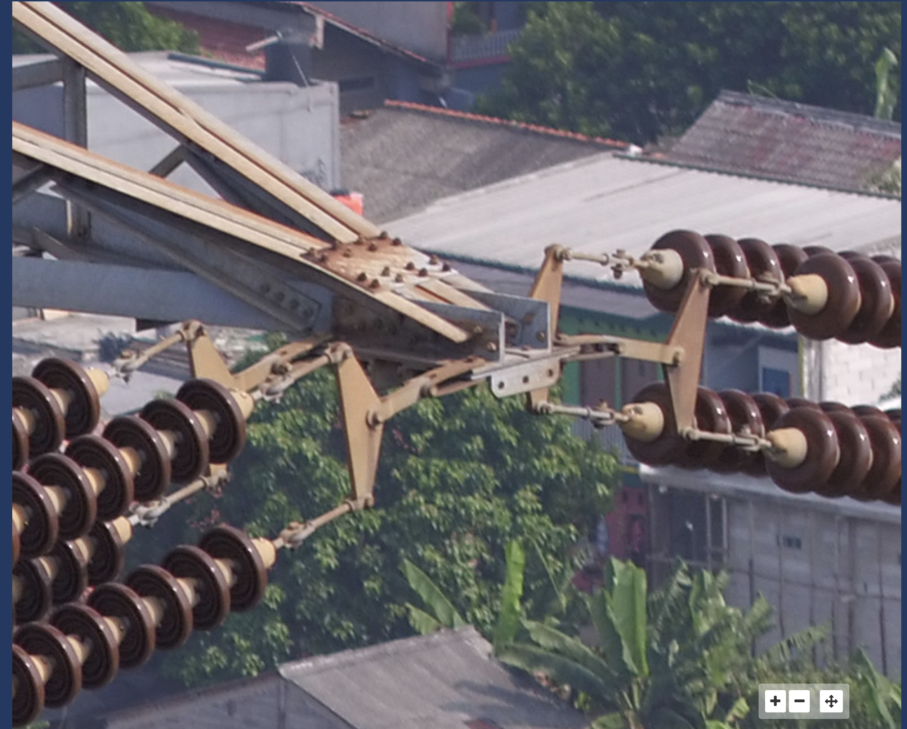

* Go back out to the T.62 Inspection Report front page
  + Select Conductor Imaging > ENE > 2 > SSE > AC
  + Select Full Screen Resolution
  + We need to find a good quality image looking into the concave part of the insulator sets
  + Go back one level and then select compare & show how this works
  + Go back & select Identified Issues
  + Again describe how all inspection issues are identified and coded per the table at the bottom for good analysis

**Maintenance Module**

* Jakarta & Tangerang > Jakarta > Kembangun Gandul > Tower #062 > Rolling 12 months (Internal: Should increase this out to previous 5 years as a time option)
* Select Report 17 March
  + Show the Maintenance Repair/Work Order & note CAM system could generate this automatically. It would be very helpful for analytical reasons to either have agreed fixed unit prices or quotes by each repair type for good analysis
  + Go to the Maintenance Repair Report
  + Go to the Job Variation Report
  + Go back to the Maintenance Repair/Work Order page & select the CAM Air Inspection report to show how this links you back to the identified issue that triggered the repair work

Internal – this is not working & need to fix

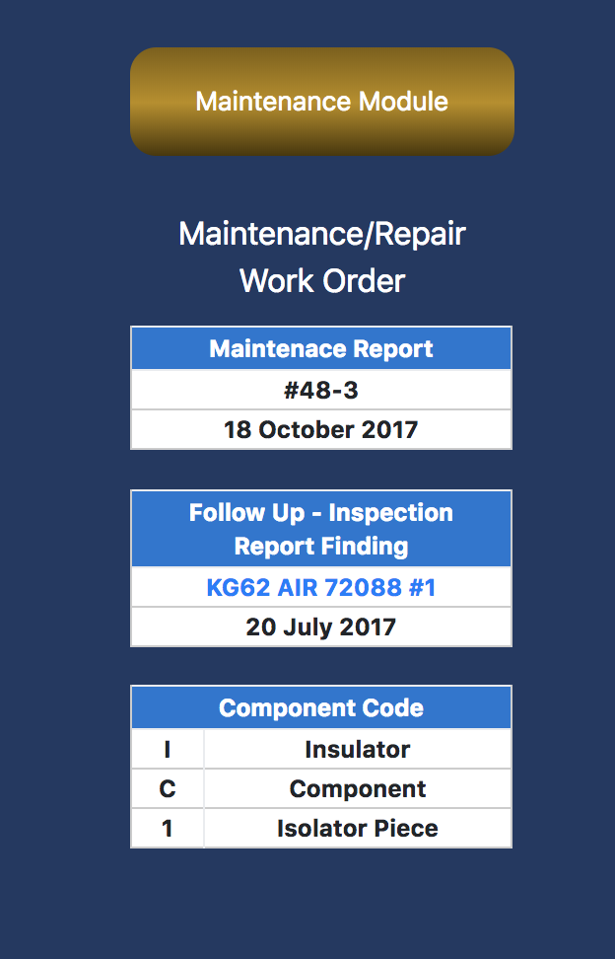

**Maintenance Analysis Module**

* Select Inspection Issues Analysis & walk through how you select Region > APP Area > Circuit & Period
* Talk to how it shows the various statistics based on priority
* Show how you can select the Maintenance Module button & it will only take you up to the top of the Maintenance Module & not all the way to the CAM System Modules
* Go through the various highest ranking issue modules & explain that they work on the worst 5 only (this is a list that your team don’t want to be on)
* Show the User Defined Urgent Issue Alert notices as relates to what was set via the user’s dashboard. Note how this could be to target to have lower threshold criteria so to proactively manage a sensitive circuit for upcoming event or for key PLN high value or critical industry clients
* Go to Dual Analysis Inquiry & set up this inquiry

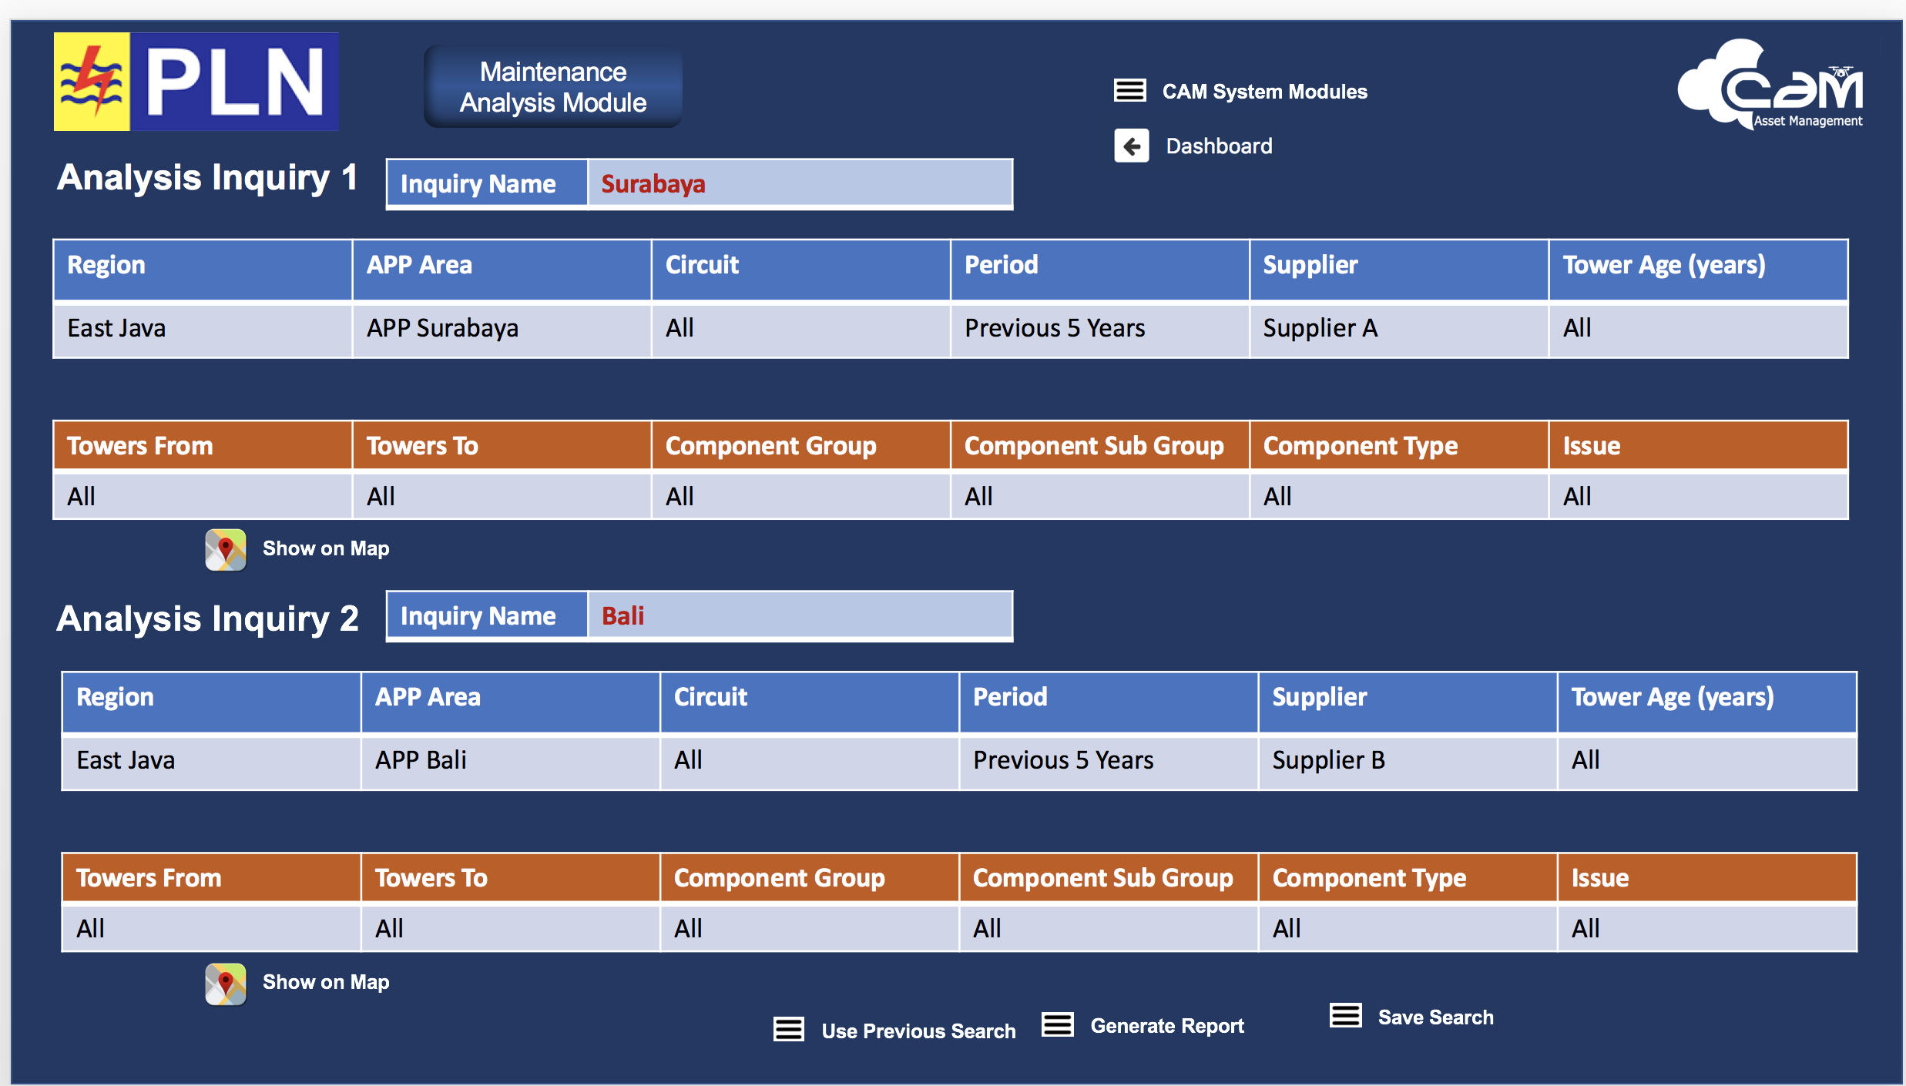

* + Note that you can save each search or export to Excel or pdf as required
  + Generate the report & walk through the numbers and note that this search could be used to compare Tower Supplier A with Tower Supplier B in terms of the maintenance performance of what they have supplied
  + Note that the analysis comes down to a cost per tower by cost type & should look like below

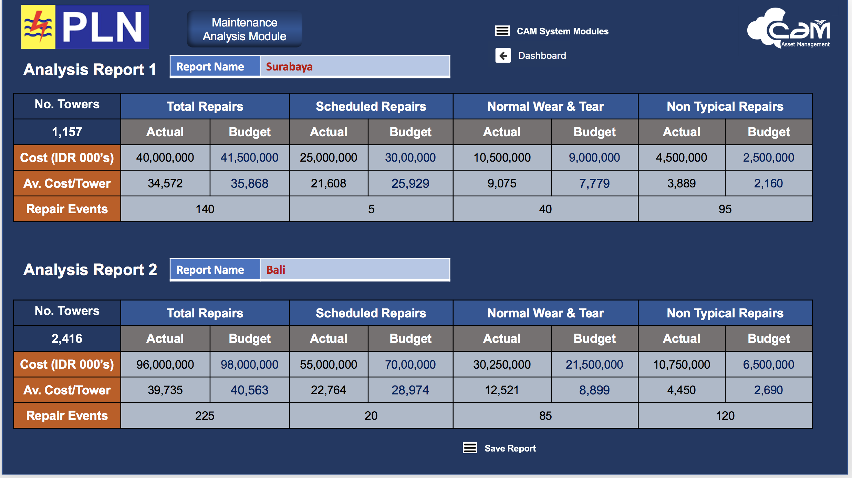

* Go back & do this inquiry

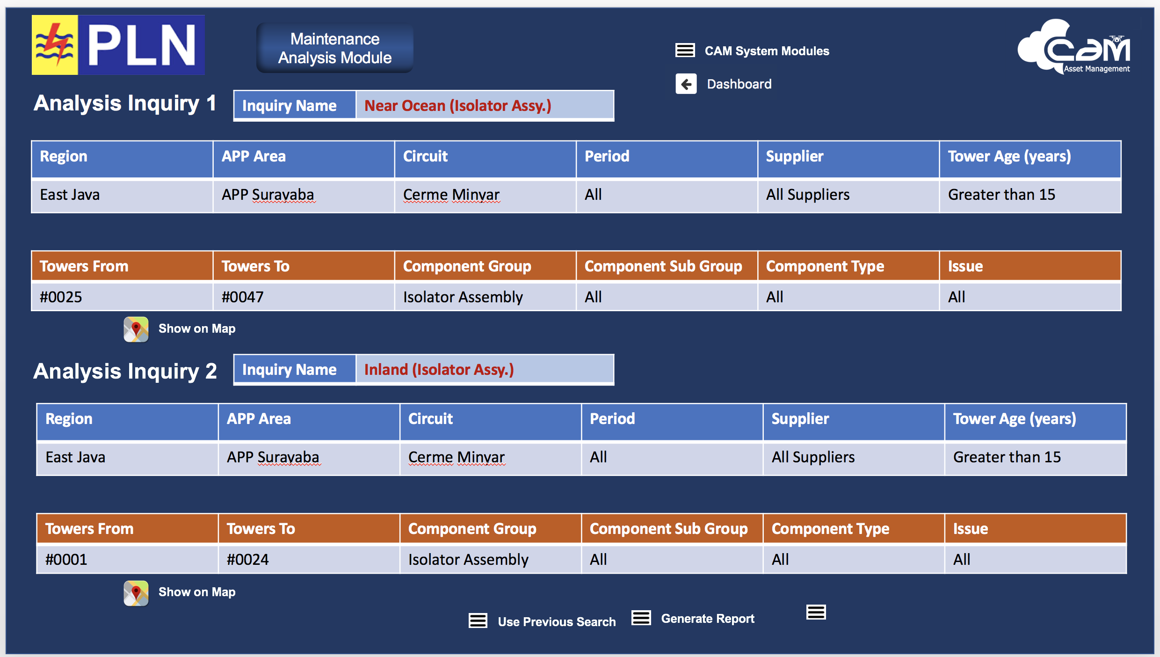

* + Select the Show on Map icon for Analysis Inquiry 1 – explain how you want to look at towers near the ocean to see what affect salt air may have on the isolator assembly
  + Select the Show on Map icon for Analysis Inquiry 2 – explain how this is the same circuit & all other parameters, however, this section of the circuit is away from the ocean
* Generate the report & note the cost per tower for maintenance for the isolator assembly is much higher than the inland towers which may require the following:
  + Earlier scheduled preventative maintenance
  + Change of the tower isolator assembly design criteria where the towers are near the ocean

**Budget Planning & Analysis Module**

* Describe how we will develop this to customise to PLN’s requirements
* Show the Tower System Cost Estimate Projections by changing some of the inflationary numbers to project our costs in future years

Ask why Bali stands for Banyak Libur??